**REPORT ON EDUCATIVE COURSE ANALYSIS**

Table of Contents

**1.0 INTRODUCTION** 1

**2.0 DATA PREPROCESSING** 2

**3.0 TOOLS USED** 2

**4.0 Questions** 2

**5.0 Hypothesis** 3

**6.0 ANALYSIS** 3

**6.1 What is the total number of subscribers for each project** 3

**6.2 What is the average duration of content per subject?** 4

**6.3 What is the average cost per subject at each level of education?** 5

**6.4 What is the total revenue per subject?** 6

**6.5 What are top5 courses by total revenue?** 7

**6.6 What is the trend of total revenue by year?** 8

**6.7 Is there a correlation between price and revenue?** 9

**6.8 What is the average rating per subject for each level of education?** 10

**6.9 Do paid courses have higher rating compared to free courses?** 11

**7.0 What is the yearly trend in average price?** 12

**8.0 FINDINGS & OBSERVATIONS** 13

**9.0 RECOMMENDATIONS** 13

**10.0 CONCLUSION** 14

# **1.0 INTRODUCTION**

In the fast-paced world of online education, data analytics plays a pivotal role in shaping strategies for course offerings, pricing, and revenue generation.

Educative is a leading education technology company that provides an interactive, hands-on learning platform for software developers, programmers, and technology enthusiasts and has a global reach, serving learners from various countries.

Educative's mission is to revolutionize the way people learn and master coding and other skills. Unlike traditional learning methods that rely heavily on textbooks and lectures, Educative's platform offers an immersive and engaging learning experience.

As a Data Analyst at Educative, a prominent education technology company, the task at hand is to delve into the company's course data to unearth insights that will not only optimize revenue streams but also enhance course performance. The Head of Curriculum at Educative has tasked me with presenting data on course revenue, with a specific focus on identifying opportunities for revenue growth and tracking course performance across various subjects.

The primary objective is to analyze the dataset following the Cross Industry Standard for Data Mining (CRISP-DM) framework and generate a comprehensive report for the manager. Additionally, I am required to create an interactive dashboard using both Excel and Power BI, catering to the preferences of stakeholders, including the CEO.

# **2.0 DATA PREPROCESSING**

The dataset comprises 3681 rows and 11 columns, offering a comprehensive view of Educative's course landscape. Each row represents a unique course within the platform, while the columns provide valuable insights into various aspects of these courses.

* The 'id' column's data type was changed from WHOLE NUMBER to TEXT.
* The 'price' column's data type was changed from WHOLE NUMBER to CURRENCY.
* Two duplicate rows were removed from the dataset.
* Three blank rows were removed from the dataset.

# **3.0 TOOLS USED**

**Excel** – For analysis and visualization

**Power BI** – For visualization

# **4.0 Questions**

After going through the data and understanding it, I came up with a number of questions that will guide my analysis.

1. What is the total number of subscribers for each subject?
2. What is the average duration of content per subject?
3. What is the average cost per subject at each level of education?
4. What is the total revenue by subject?
5. What are the top 5 courses by total revenue?
6. What is the revenue trend by year?
7. Is there correlation between price and revenue?
8. What is the average rating per subject for each level of education?
9. Do paid courses have a higher average rating compared to free courses?
10. What is the average price of courses by year?

# **5.0 Hypothesis**

**Null hypothesis**

1. The popularity of web development courses is not significantly different from the popularity of other courses offered.
2. Increasing prices of web development courses does not lead to increased revenue.

**Alternate hypothesis**

1. Web development courses have a significantly higher popularity compared to other courses offered.
2. Increasing prices of web development courses leads to increased revenue.

# **6.0 ANALYSIS**

## **6.1 What is the total number of subscribers for each project**

|  |  |
| --- | --- |
| **subject** | **Total subscribers** |
| Web Development | 7,981,935 |
| Business Finance | 1,868,711 |
| Graphic Design | 1,063,148 |
| Musical Instruments | 846,689 |
| **Grand Total** | **11,760,483** |

* Web Development emerges as the most subscribed subject, with a total of 7,981,935 subscribers.

This indicates a strong demand for courses related to web development skills, suggesting a significant market opportunity within this subject area. Given the substantial number of subscribers, it is evident that the popularity of web development courses is significantly higher than that of other courses offered. Therefore, we reject the null hypothesis, concluding that the popularity of web development courses is indeed significantly different from the popularity of other courses.

## **6.2 What is the average duration of content per subject?**

|  |  |
| --- | --- |
| **Subject** | **Average Content Duration** |
| Web Development | 5.6 |
| Graphic Design | 3.6 |
| Business Finance | 3.6 |
| Musical Instruments | 2.9 |
| **Grand Total** | **4.1** |

* Web Development courses have the highest average content duration of 5.6 hours among the subjects listed.
* Graphic Design and Business Finance courses have the second highest average content duration of 3.6 hours each
* Musical Instruments courses have the lowest average content duration of 2.9 hours.

This suggests that Web Development courses tend to have more comprehensive and in-depth content compared to courses in other subjects offered by Educative. The longer duration could be an indicator of the breadth and complexity of topics covered in these courses, making them potentially more valuable to students interested in web development.

## **6.3 What is the average cost per subject at each level of education?**

|  |  |  |
| --- | --- | --- |
| **subject** | **level** | **Average price** |
| **Web Development** | Intermediate Level | $85.07 |
|  | Beginner Level | $78.54 |
|  | All Levels | $74.55 |
|  | Expert Level | $67.14 |
| **Web Development Total** | | **$77.04** |
| **Business Finance** | All Levels | $70.20 |
|  | Beginner Level | $68.73 |
|  | Expert Level | $65.80 |
|  | Intermediate Level | $62.01 |
| **Business Finance Total** | | **$68.69** |
| **Graphic Design** | All Levels | $62.12 |
|  | Intermediate Level | $59.41 |
|  | Beginner Level | $50.68 |
|  | Expert Level | $28.57 |
| **Graphic Design Total** |  | **$57.89** |
| **Musical Instruments** | Intermediate Level | $51.60 |
|  | All Levels | $49.58 |
|  | Beginner Level | $48.98 |
|  | Expert Level | $48.33 |
| **Musical Instruments Total** | | **$49.56** |
| **Grand Total** |  | **$66.12** |

* Web Development courses have the highest overall average price of $77.04 across all levels.
* Within Web Development, Intermediate level courses have the highest average price of $85.07.
* Business Finance has the second highest overall average price of $68.69 after Web Development.
* For Business Finance, the "All Levels" category has the highest average price of $70.20.
* Graphic Design courses have a lower overall average price of $57.89 compared to Web Development and Business Finance.
* Musical Instruments courses have the lowest overall average price of $49.56 across all subjects.
* Across all subjects, the Intermediate level tends to have higher average prices compared to other levels like Beginner and Expert.

This suggests that Web Development and Business Finance courses command higher prices, with Web Development being the most expensive subject overall. The pricing strategy seems to be tiered based on the course level, with Intermediate courses fetching the highest average prices, perhaps due to their advanced technical depth. Musical Instruments courses appear to be the most affordable option overall.

## **6.4 What is the total revenue per subject?**

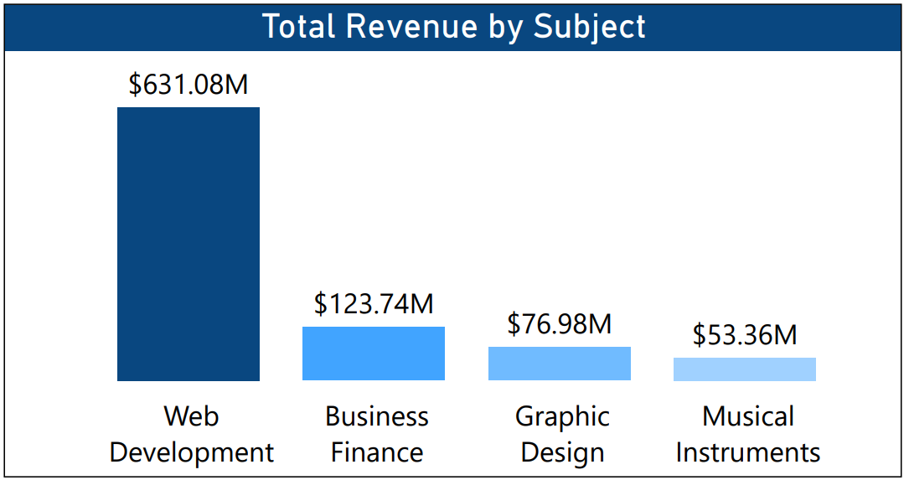

The chart indicates that Web Development courses generate the highest revenue, suggesting significant demand and a lucrative market opportunity within this subject area. While other subjects like Business Finance, Graphic Design, and Musical Instruments also contribute to revenue generation, Web Development stands out as the most profitable category. This underscores the importance of understanding revenue distribution across different subjects to inform strategic decisions and resource allocation within the company.

## **6.5 What are top5 courses by total revenue?**

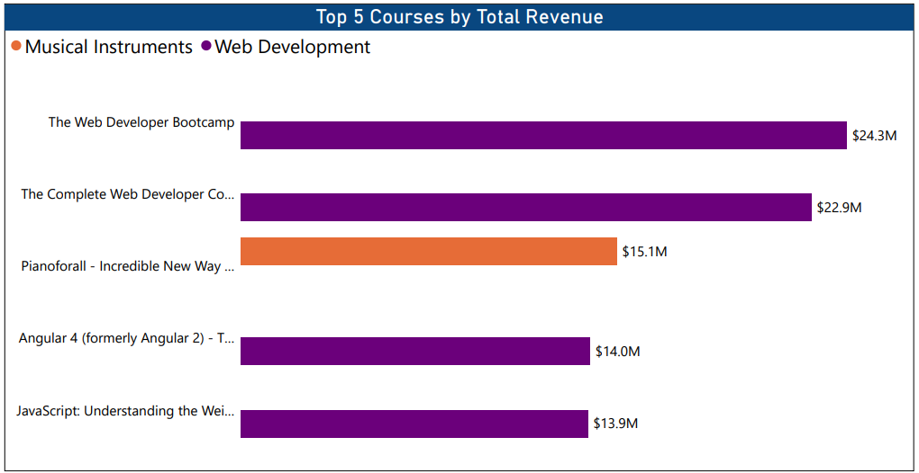

The chart shows that Web Development courses generate the highest revenue, indicating significant demand in this subject area. While other subjects like Musical Instruments also contribute to revenue, the dominance of Web Development suggests its popularity among learners. Certain courses within Web Development stand out as major revenue drivers, highlighting potential opportunities for further course development and expansion.

## **6.6 What is the trend of total revenue by year?**

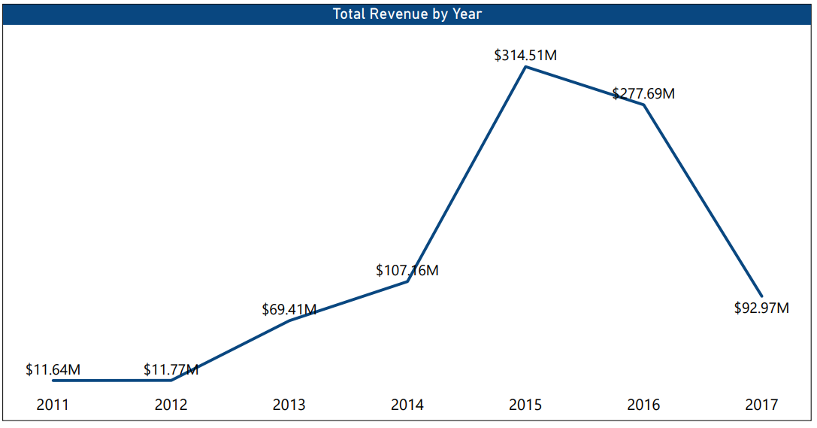

The chart indicates a general trend of increasing revenue from 2011 to 2015, with a peak in 2015, followed by a decrease in revenue in 2016 and 2017. This suggests fluctuations in market platform performance over the years, highlighting the need for ongoing analysis and adaptation of business strategies.

## **6.7 Is there a correlation between price and revenue?**

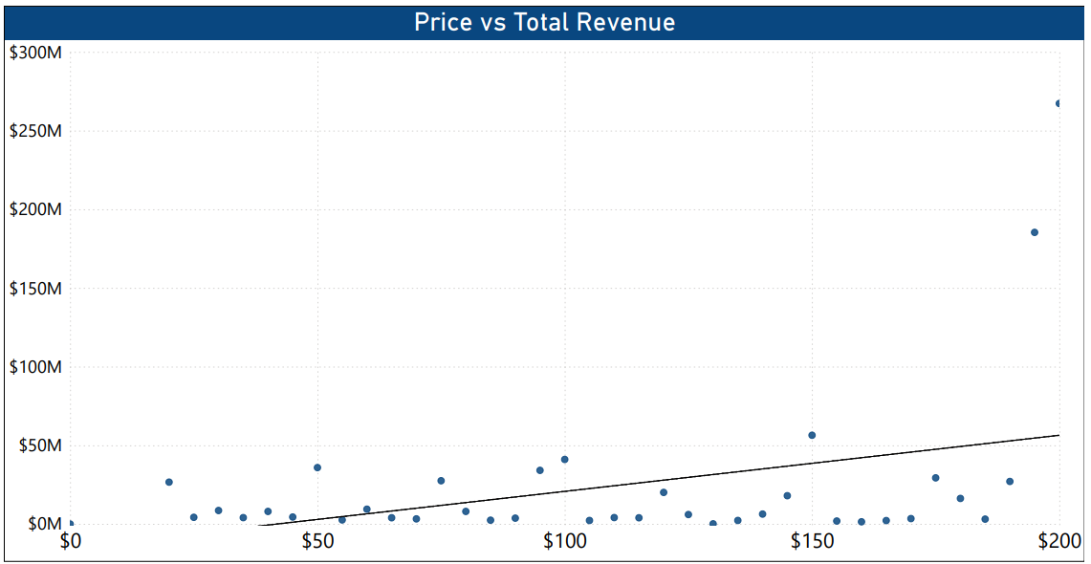

The scatter plot shows a generally positive correlation between price and total revenue, where higher prices tend to generate higher total revenue. However, the correlation is not perfectly linear due to fluctuations and deviations at certain price points. The data exhibits multiple local peaks in total revenue at different price levels, suggesting potential optimal pricing points for different customer segments. At the same time, there are instances of significant drops in total revenue compared to adjacent prices, indicating varying levels of price sensitivity among customers. The highest total revenue is observed at the highest price point, but there are also potential outliers with unusually high or low revenues compared to the general trend. Overall, the data suggests a positive price-revenue relationship with market segmentation.

The positive correlation observed in the scatter plot data suggests that higher prices tend to generate higher total revenue, indicating that increasing prices may indeed lead to increased revenue, at least within the observed range of prices. Additionally, the presence of multiple local peaks in total revenue at different price levels implies potential optimal pricing points for different customer segments, further supporting the notion that increasing prices can lead to increased revenue.

Therefore, based on the analysis provided, it seems appropriate to reject the null hypothesis and conclude that increasing prices of web development courses may lead to increased revenue.

## **6.8 What is the average rating per subject for each level of education?**

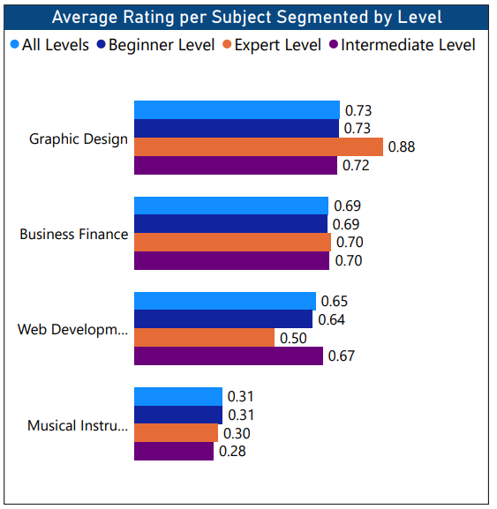

* Courses in Graphic Design tend to receive higher average ratings compared to other subjects across all skill levels.
* Expert Level courses generally receive higher average ratings compared to other skill levels in Graphic Design and Business Finance.
* In contrast, Expert Level courses in Web Development have the lowest average ratings.
* Beginner Level courses consistently receive high ratings across different subjects, especially in Musical Instruments.

The higher ratings of Graphic Design courses across all skill levels suggest effective course design and alignment with learners' needs. Expert Level courses excel in Graphic Design and Business Finance, while Web Development's Expert Level courses lag in ratings, potentially due to content complexity. Beginner Level courses consistently receive high ratings, indicating their accessibility and clarity, particularly in subjects like Musical Instruments.

## **6.9 Do paid courses have higher rating compared to free courses?**

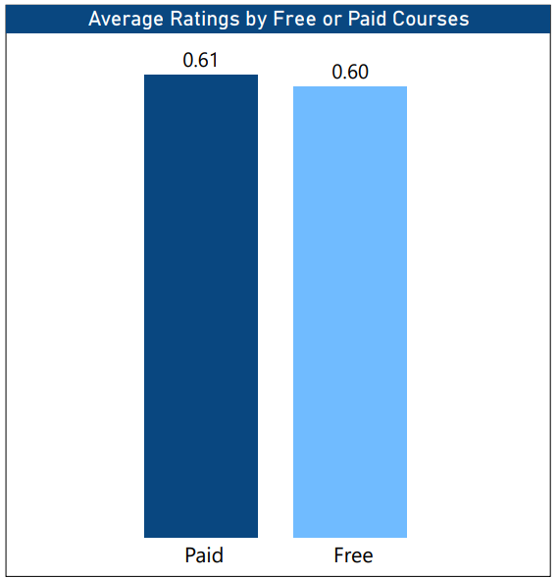

The data reveals that paid courses have a slightly higher average rating (0.612) compared to free courses (0.596).

This suggests that, on average, users perceive paid courses to offer slightly better value or quality compared to free offerings.

## **7.0 What is the yearly trend in average price?**

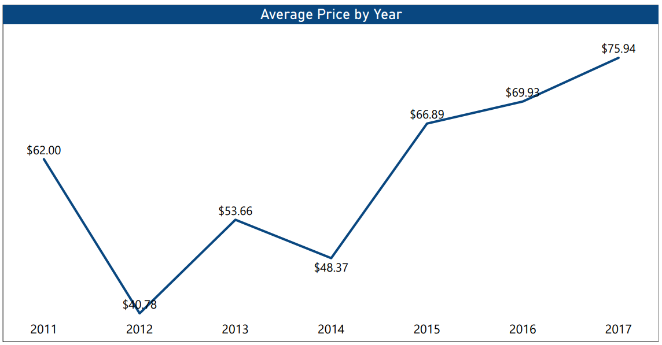

The chart shows fluctuations in the average price of courses over the years. There is an increase in average prices from 2011 to 2012, followed by a decrease in 2013. Prices then fluctuate, with a notable increase from 2014 to 2017.

This suggests a dynamic pricing strategy influenced by various factors such as market demand and course content.

# **8.0 FINDINGS & OBSERVATIONS**

* Web Development courses have the highest subscriber count, indicating significant demand and a lucrative market opportunity.
* Web Development courses tend to have longer content durations compared to other subjects, suggesting comprehensive and in-depth coverage.
* Web Development and Business Finance courses command higher prices on average compared to other subjects.
* Intermediate-level courses generally have higher average prices across all subjects.
* Graphic Design courses receive higher average ratings compared to other subjects, especially at the Expert level.
* Paid courses tend to have slightly higher average ratings compared to free courses.
* There are fluctuations in the average price of courses over the years, suggesting a dynamic pricing strategy influenced by market demand and course content.

# **9.0 RECOMMENDATIONS**

1. Focus on web development courses since they are the most popular. Prioritize investments and resources towards expanding and enhancing the Web Development course offerings.
2. Adjust pricing accordingly to maintain competitiveness in web development courses by conducting regular market research to stay informed about competitor pricing strategies and industry trends.
3. Given the fluctuations in course prices over the years, adopt a flexible pricing strategy that responds to changes in market conditions, learner preferences, and competitive pressures. Regularly review pricing strategies and adjust prices as needed to maximize revenue while remaining competitive.
4. Focus on developing and promoting Intermediate-level courses, as they seem to be in higher demand and command higher prices, particularly in Web Development and Business Finance.
5. Continuously monitor course ratings and feedback to identify areas for improvement and ensure high-quality learning experiences. Invest in course development, instructor training, and instructional design to maintain high standards and meet learner expectations.

# **10.0 CONCLUSION**

Educative should prioritize web development courses as they are found to be the most popular, profitable, and command the highest average prices compared to other subjects. The longer content duration of these courses also contributes to their perceived value and high demand among learners.

The data analysis rejects the hypothesis that web development course popularity is not significantly different from other courses. Instead, it clearly shows web development as the most in-demand offering, making it a strategic priority.

To capitalize on this, the company should invest in expanding and enhancing its web development course catalog, developing new advanced courses, updating existing ones with latest trends, and ensuring high-quality engaging content.

Additionally, a tiered pricing strategy specific to web development courses is recommended, leveraging the positive price-revenue correlation and presence of multiple revenue peaks at different price points. This can involve varied pricing tiers based on course depth, premium versions with added features, and competitive pricing aligned with industry standards.

Overall, focusing investments on the highly popular and profitable web development courses, coupled with a strategic pricing approach, market monitoring, and meeting learner needs can strengthen the company's position, increase revenue, and provide valuable learning experiences.